**Project Title: Linux Systems Log & Password Manager**

**Submitted to:**

**[ Md. Emon Islam Rabbi ]**

**[Lecturer]**

(City University, Dhaka)

**Submitted By:**

**[ Sharmin ]**

[ ID: 171442621 ]

[ Batch: 44th ]

[ Group-7 ]

[ Department of CSE ]

(City University, Dhaka)

Table of Contents

**Introduction** 3

**Password Management:** 3

**Objectives** 3

**Features** 3

**Methodology** 4

**Workflow Diagram:** 5

**Tools used in the project:** 6

**UML diagram (Use Case):** 6

**Conclusion** 7

**Contribution:** 7

# **Introduction**

## **Password Management:**

Passwords are a set of strings provided by users at the authentication prompts of web accounts. Although passwords still remain as one of the most secure methods of authentication available to date, they are subjected to a number of security threats when mishandled. The role of password management comes in handy there. Password management is a set of principles and best practices to be followed by users while storing and managing passwords in an efficient manner to secure passwords as much as they can to prevent unauthorized access.

**Objectives**1. To provide System Administrator or IT people a single platform to work with various systems.

3. To provide the facility of central Linux/Unix Password Management System.

# **Features**

1. Linux System Password Management
2. Multiple Device Support
3. Changing Password without directly interacting with the system
4. WEB based application
5. Unlimited User Access
6. Role based user authorization
7. Secured.

# **Methodology**

The waterfall model is a linear, sequential approach to the software development life cycle (SDLC) that is popular in software engineering and product development. The waterfall model emphasizes a logical progression of steps. Similar to the direction water flows over the edge of a cliff, distinct endpoints or goals are set for each phase of development and cannot be revisited after completion. The term was first introduced in a paper published in 1970 by Dr. Winston W. Royce and continues to be used in applications of industrial design.

To accomplish this project we have choose waterfall methodology for several purpose. These are listed below:

1. Stable Requirement: The main purpose of choosing this methodology is, we have stable or known requirement for this project. Which is the root element of waterfall methodology.
2. Product definition is stable: For this proposed solution the entire product workflow is stable. There is no ambiguity about the workflow of this product.
3. Technology is understood: We have a clear understanding of the proposed project which will help us to complete the entire project.
4. The project is short: The proposed system is not so huge so waterfall is in our favor to develop such Application.

# **Workflow Diagram:**



Fig-01: Project Workflow Diagram

**Tools used in the project:**

1. Eclipse
2. MySQL workbench
3. Notepad++
4. Browsers. (i.e. Firefox, Internet Explorer, Google Crome)
5. JUNIT
6. Java Development Kit

# **UML diagram (Use Case):**



Fig-02: Use Case Diagram

# **UML Diagram (Class Diagram):**



Fig-03: Class Diagram

# **Conclusion**

This project will help System Administrator’s or IT Peoples to monitor their Linux Systems and manage their credentials more efficiently from a single platform within an Organization. As this project is web based and have multiple device compatibility, so the system can be accessed from any device from anywhere. The only tools is required a browser which have access to the server through a network.

# **Contribution:**

1. 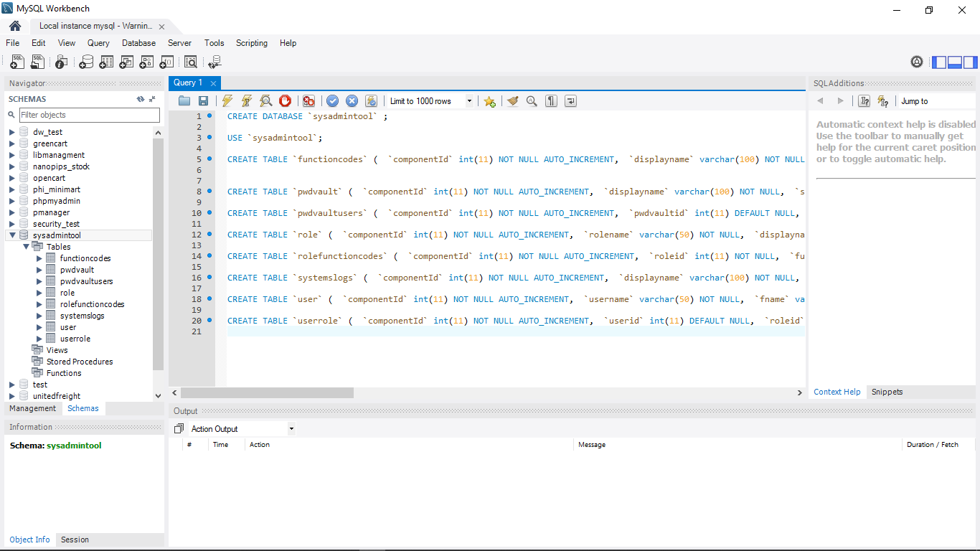Development of the Database Queries used into the project.